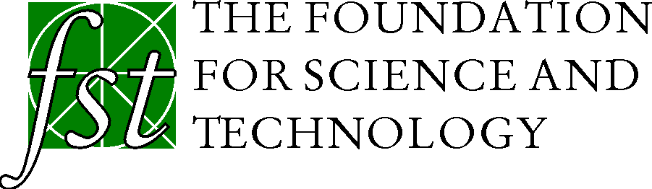

Opportunities for Part-Sponsorship of Foundation for Science and Technology Events

The Foundation for Science and Technology (www.foundation.org.uk) organises discussion events bringing together government, Parliament, industry and the research community, to discuss science, technology and innovation issues of relevance to all these groups. The FST is a UK-registered charity, and is funded by a mixture of subscribing members, grants and event sponsorship.

The Foundation makes no charge to participants at its events. It is only able to run a series of major discussion events thanks to sponsorship. Each event is typically part-sponsored by between two and four organisations. A typical sponsorship contribution is £5,000 plus VAT, but there is flexibility for both larger and smaller sponsorship amounts.

The benefits offered to organisations sponsoring an FST event are:

- Mention of sponsors in the event programme
- Mention of sponsors by the event Chairman at the beginning and end of the events
- Distribution of sponsors’ material with the event programme [Single page A5 flyers can be inserted into each programme, otherwise material can be handed out with programmes]
- A pull-up banner displayed prominently at the event
- A seat at the speakers table (over dinner)
- The right to nominate up to 8 people to attend the event, who can have reserved seats in the auditorium.

Organisations interested in sponsoring an FST event may contact the Chief Executive of the Foundation, Gavin Costigan, at: gavin.costigan@foudation.org.uk, tel: 020 7321 2220.

