Report: Elsevier Roundtable on AI and the Future of Research
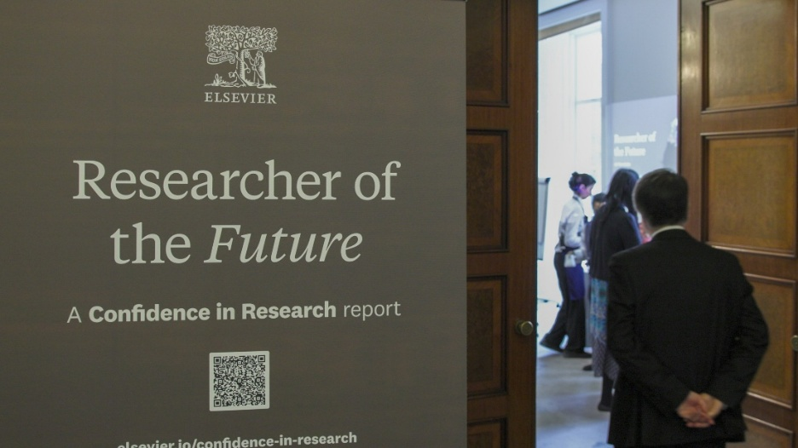
About
This roundtable was organised by Elsevier in collaboration with The Foundation for Science and Technology and formed the first in a series of international discussions exploring how artificial intelligence (AI) is reshaping research systems worldwide.
The group met on Thursday 12th March 2026 at the Royal Society. They focused on identifying practical, policy-oriented actions that could strengthen the UK’s research environment in an era of rapid technological change.
Elsevier shared findings from its ongoing Researcher of the Future initiative, based on insights from more than 3,200 researchers across 113 countries. The session examined the UK-specific data set, discussed institutional and cultural responses, and explored how AI might influence productivity, creativity, research integrity, and policy frameworks.
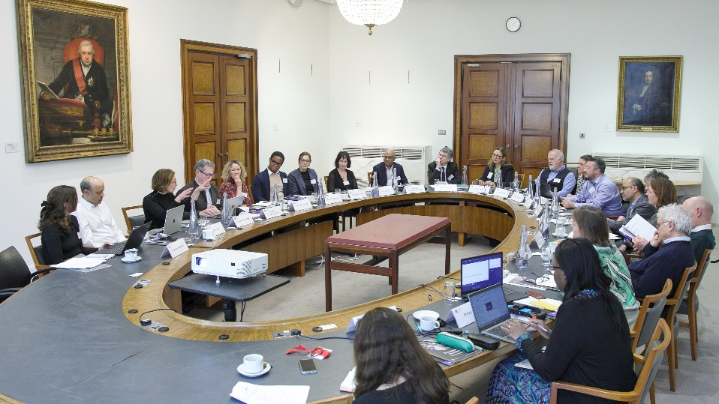
Attendees included:
- Tracey Brown, Director, Sense about Science
- Gavin Costigan, (Former) Chief Executive, Foundation for Science and Technology
- Helen Coulshed, Associate Vice Dean Education and Senior Lecturer in Chemistry Education, King’s College London
- Camilla D'Angelo, Policy Manager, CASE
- Esra Erkal, Executive Vice President, Global Communications, Elsevier
- Catriona Firth, Associate Director, Research Environment, Research England
- Pallab Ghosh, Science Correspondent, BBC
- Laura Hassink, Managing Director for STM Journals, Elsevier
- Sudesh Kumar, President of AIRTO and Vice-President Health, University of Warwick and AIRTO
- Sarah Main, Vice President Academic and Government Relations UK, Elsevier
- Geoffrey Neale, Lecturer in Multifunctional Composite Structures, Cranfield University
- Paul Nurse, President, Royal Society
- Lawrie Phipps, Director of External Policy Development, Jisc
- Hetan Shah, Chief Executive, British Academy
- Vivienne Stern, Chief Executive, Universities UK
- Dominic Tate, Deputy Director of Library and University Collections, University of Edinburgh
- Lesley Thompson, Vice President, Funders, Global Business Development, Elsevier
- David Willetts, Chair, Foundation for Science and Technology
- James Wilsdon, Exec Director, Research on Research Institute, UCL

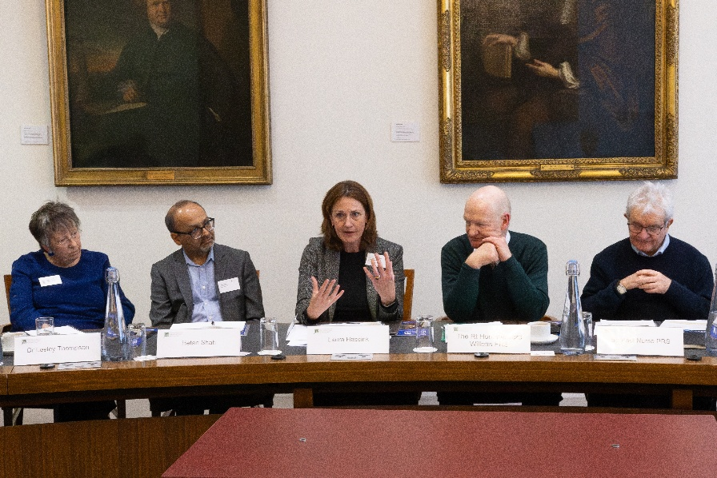
Key Themes and Insights
- Adoption is rising, but confidence in lagging
"Skepticism has value if it helps us build better and more responsible systems" - Roundtable participant
- Around half (52%) of UK researchers now use AI tools in their work, mirroring global adoption levels.
- Uptake has grown sharply (by over 20 percentage points in a year), but UK researchers are notably more cautious than their international peers.
- Confidence is lower in areas such as trustworthiness, ethical development, and governance of AI tools.
- This caution reflects a culture that focuses on integrity and quality, though it could also slow innovation if not paired with clearer guard rails. UK researchers are notably more cautious when it comes to trust, ethics, and the role of AI in advancing discovery. According to the report’s findings, around 11% of UK researchers say AI is trustworthy, and only 5% believe AI tools are ethically developed.

2. AI as a Productivity Tool, not a Creative Partner
- AI is widely valued for efficiency gains—for example, data analysis, and automating repetitive processes.
- However, participants noted that AI often produces the “obvious answer” quickly, which is useful but may limit deeper or more novel inquiry.
- Participants stressed that AI can answer questions, but cannot reliably ask the right ones, which is central to scientific breakthroughs. Concerns were raised that AI-generated material can appear plausible but lacks originality or true insight, potentially contributing to a homogenisation of research outputs.
- This dynamic risks reinforcing conservative thinking and reducing the diversity of research voices and ideas.

3. UK Caution as a Possible Competitive Strength
- Several voices argued that the UK’s careful, ethics-led approach could become a distinctive advantage internationally, positioning it as a hub for high-integrity, quality-focused research.
- Rather than chasing scale and speed, the UK could emphasise “responsible excellence”—balancing innovation with rigorous oversight.
- Achieving this will require sustained investment in skills development, data quality, and public trust in research.

4. The ‘Assessment Gap’ - Support, and Governance
- A recurring theme was the absence of structured institutional support for researchers using AI.
  - There is a growing “assessment gap”, where AI use is disclosed but evaluators lack the capability to judge it effectively.
  - Only 13% of UK researchers report receiving sufficient training in AI tools—much lower than the global average which stands at 27%.
  - Governance arrangements and guidance remain inconsistent across institutions.
  - Researchers are not just under-trained; they are concerned about retrospective accountability (being judged later for current AI use)
- Many researchers are learning through experimentation, leaving them uncertain about ethical boundaries, data management, and disclosure expectations.
- Participants called for centralised, cross-institutional guidance rather than fragmented local policies.

5. Systemic Pressures and Incentive Structures
- Broader research system challenges—funding constraints, shrinking time for research, and incentives that reward volume and polish—shape how AI is being used. This creates a system-level challenge, not just an individual behaviour issue, requiring redesign of evaluation processes.
- Funders are already seeing sharp increases in application volumes, likely driven by AI-assisted proposal writing. AI enables higher throughput of proposals and publications, potentially making it harder to identify high-quality, original research.
- Participants warned that this could lead to an oversupply of “well-written” work with limited novelty, while genuine breakthroughs risk being crowded out.
6. Trust, Integrity, and Data Bias
- Trust and research integrity were central concerns.
  - Participants noted risks from biased or incomplete datasets, opaque AI models, and unverified outputs.
  - There were calls for transparency about how AI is used in research design, data analysis, and writing.
- Discussion emphasised the need to differentiate between types of AI—ranging from assistive tools to autonomous systems—with distinct ethical and governance implications.
- Real-world risks already visible (e.g. biased health outcomes from unrepresentative datasets). Greater openness about negative or null results was viewed as important to counteract publication bias and strengthen research credibility.
7. Training, Skills, and the Role of Support Services such as Libraries
- Training emerged as a top priority, extending beyond students to faculty, supervisors, and research professionals.
- Concern that overuse of AI (e.g. for literature reviews) may undermine researcher development, especially for early-career researchers.
- Participants saw libraries and research support offices as critical infrastructure for research literacy and expertise for critical thinking, ethical use, and data governance.
- The goal is to enable researchers to use AI thoughtfully—to prompt deeper analysis and reflection, not replace it.
8. Towards Action and Policy
- The roundtable concluded with a shared sense of urgency to move from uncertainty to clear cross-sector principles.
- Recommended areas for action included:
  - Need for flexible frameworks that evolve with technology, rather than static regulation.
  - Integrating training on AI ethics and data management at all career stages.
  - Creating mechanisms for sharing negative findings and improving data transparency.
  - Encouraging collaboration across academia, funders, and publishers to ensure consistent standards.
  - Supporting research on AI’s social, cultural, and ethical impacts alongside technical developments.
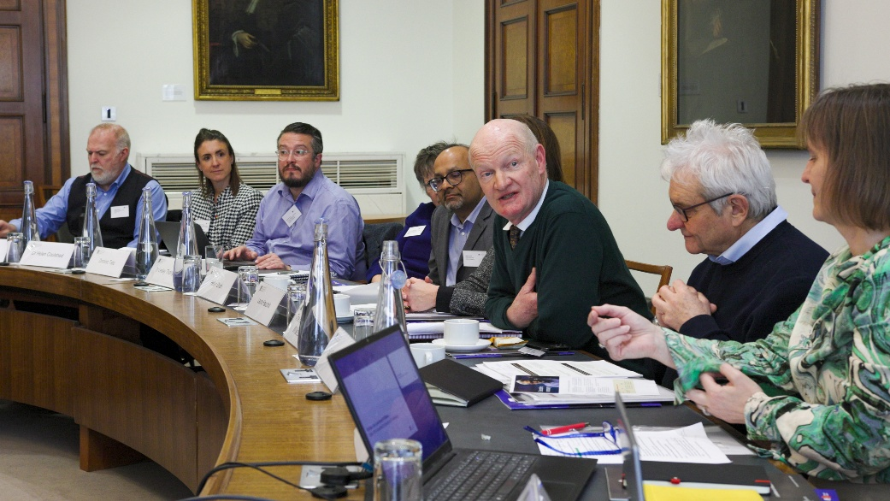

9. AI is not a single category
- Participants repeatedly stressed that AI includes very different tools and capabilities
- Policy and governance should be use-case specific, not one-size-fits-all
- Potential need for tool accreditation or trust markers

10. Rethinking productivity in research
- Strong challenge to the idea that more output equals better science
- Need to redefine productivity beyond volume and funding capture
- Risk of losing intellectual diversity and distinctive research voices

Conclusion
Researchers do not want AI to replace thinking, but to create more space for it.
The discussion reflected both optimism and unease about AI’s growing role in research. UK researchers are adopting AI at pace but remain cautious—an attitude that could become a strength if it leads to robust, trustworthy, and creative science.
The path ahead will depend less on promoting AI adoption and more on building competence, confidence, and clarity: ensuring that tools accelerate high-quality research without eroding the values and rigour that underpin the UK’s scientific reputation.

